Create your own Sustainability Policy with ABDO #ThinkingGreen
What is a sustainability policy?
Sustainability can be described as avoiding the depletion of natural resources to maintain an ecological balance. A sustainability policy is a statement explaining your business’s thinking and commitment to the aspects of sustainability that you can influence in your practice.
Why develop a sustainability policy?
Optical businesses are under more pressure than ever to meet environmental responsibilities. Your customers have increasing expectations of businesses to reduce their waste, reduce their carbon footprint and to improve their sustainability performance. A sustainability policy demonstrates your commitment to an ethical and environment-friendly way of working
How a sustainability policy can help YOUR business
The design and implementation of a sustainability policy may require some initial investment – but there are advantages. A sustainability policy will help you to:
- Meet upcoming environmental legislation.
- Use less energy, create less waste, and so reduce your costs.
- Ensure employees and colleagues feel good about working in your business.
- Enhance your reputation with environmentally conscious customers.

(Refer to ISO 14001 certification for further information to help your business)

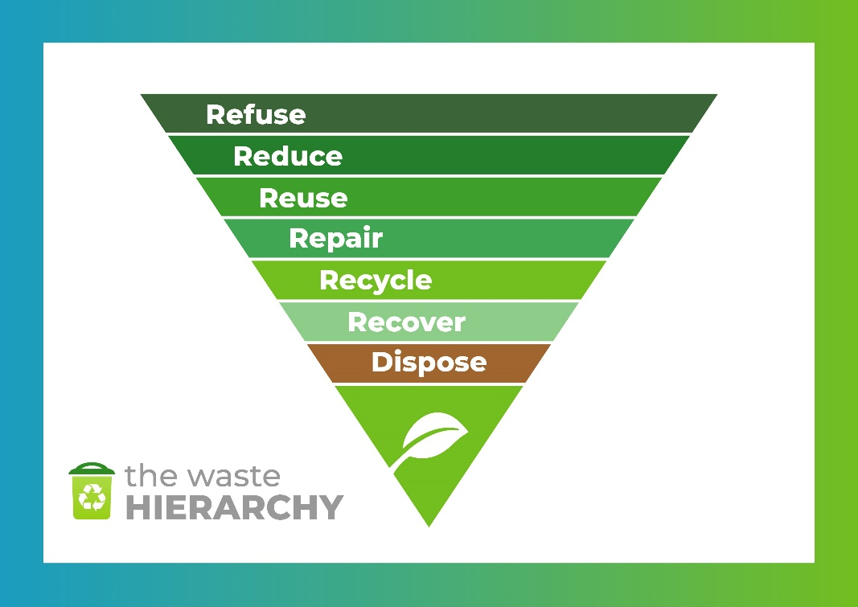

Sustainability policy template
There is no standard layout for a sustainability policy as each business is different in size and with varying local issues and priorities. Here are some considerations for a balanced sustainability policy.

GREEN OPTICIANS - OUR SUSTAINABILITY POLICY
VISION
The vision statement concisely describes your ideal aims in 10 words or less.
Caring for the environment is an integral to our thinking.
PRINCIPLES
Creating a list of principles helps you to decide what is most important.
At Green Opticians we recognise the harm caused to the local and global environment from continued use of non-recyclables and we commit to reduce this in our business.
At Green Opticians we will measure our impact on the environment and set targets to improve our performance.
IMPORTANT ISSUES
Which challenge is most important to your business and colleagues? Waste? Recycling? Ethically sourced products?
Our business faces some real challenges, but there are also opportunities. We seek to reduce our Carbon Footprint by reducing waste, cutting unnecessary travel to meetings, and investing in an energy audit to reduce our consumption.
SCOPE
Your policy should cover areas that you can directly influence within the practice with the team, so you may need to establish boundaries.
We acknowledge that we have limited influence over our suppliers in the optical industry and beyond, but we commit to educate the wherever possible, and create a list of preferred suppliers who support our ideals.
OBJECTIVES
These are best in the SMART format (Specific, Measureable, Achievable, Relevant and Timed). Have an Indicator (what you measure) and a Target (level of performance). Make these realistic so that you achieve your targets and build on them to encourage your team.
We commit to:
- Completing the ABDO Sustainability Self Assessment, then updating it regularly and sharing progress with the team at the monthly meeting (from baseline x% score target y% improvement).
- Reducing team travel by car by use of public transport wherever possible (saving 100 car miles per month).
- Ensure our supply chain has responsible ethical and social responsibility for the provenance of our products (x% of frames from recycled sources by month 3).
- Give back to the community that supports the practice (Each colleague to do 2 hours volunteering per month to achieve 100 hours for the year).
REPORTING
Your stated intention to report your sustainability performance:
- We will report our performance on the company website and update quarterly.
- Senior Management Team will conduct a full review at their monthly meeting.
- Current performance features on Team Noticeboard and updated monthly.

YOUR SUSTAINABILITY POLICY
VISION
The vision statement concisely describes your ideal aims in 10 words or less.
……………………………………………………………………………………………………………………………………………………….
PRINCIPLES
Creating a list of principles helps you to decide what is most important.
……………………………………………………………………………………………………………………………………………………….
……………………………………………………………………………………………………………………………………………………….
……………………………………………………………………………………………………………………………………………………….

IMPORTANT ISSUES
Which challenge is most important to your business and colleagues? Waste? Recycling? Ethically sourced products?
……………………………………………………………………………………………………………………………………………………….
……………………………………………………………………………………………………………………………………………………….
……………………………………………………………………………………………………………………………………………………….
……………………………………………………………………………………………………………………………………………………….

SCOPE
Your policy should cover areas that you can directly influence within the practice with the team, so you may need to establish boundaries.
……………………………………………………………………………………………………………………………………………………….
……………………………………………………………………………………………………………………………………………………….
……………………………………………………………………………………………………………………………………………………….
……………………………………………………………………………………………………………………………………………………….
……………………………………………………………………………………………………………………………………………………….

OBJECTIVES
These are best in the SMART format (Specific, Measureable, Achievable, Relevant and Timed). Have an Indicator (what you measure) and a Target (level of performance). Make these realistic so that you achieve your targets and build on them to encourage your team.
We commit to:
……………………………………………………………………………………………………………………………………………………….
……………………………………………………………………………………………………………………………………………………….
……………………………………………………………………………………………………………………………………………………….
……………………………………………………………………………………………………………………………………………………….
……………………………………………………………………………………………………………………………………………………….
……………………………………………………………………………………………………………………………………………………….
……………………………………………………………………………………………………………………………………………………….

REPORTING
Your stated intention to report your sustainability performance:
……………………………………………………………………………………………………………………………………………………….
……………………………………………………………………………………………………………………………………………………….
……………………………………………………………………………………………………………………………………………………….
……………………………………………………………………………………………………………………………………………………….
……………………………………………………………………………………………………………………………………………………….
……………………………………………………………………………………………………………………………………………………….

